Select Disk

Select ur OS Hard disk

Create its copy , Address of Disk is called Snapshot

Subscription and location has to be same

Standard HDD : low cost, mass storage , ideal for snapshot , less accessed (IDEAL STORAGE ACCOUNT FOR BACKUP) NOT ACCESSED ON DAILY BASIS

Premium is for intensive enterprise workloads. For low latency and high availability

As we need backup so we will use Standard

So u will have copy of OS disk

Check it in ur Resource Group

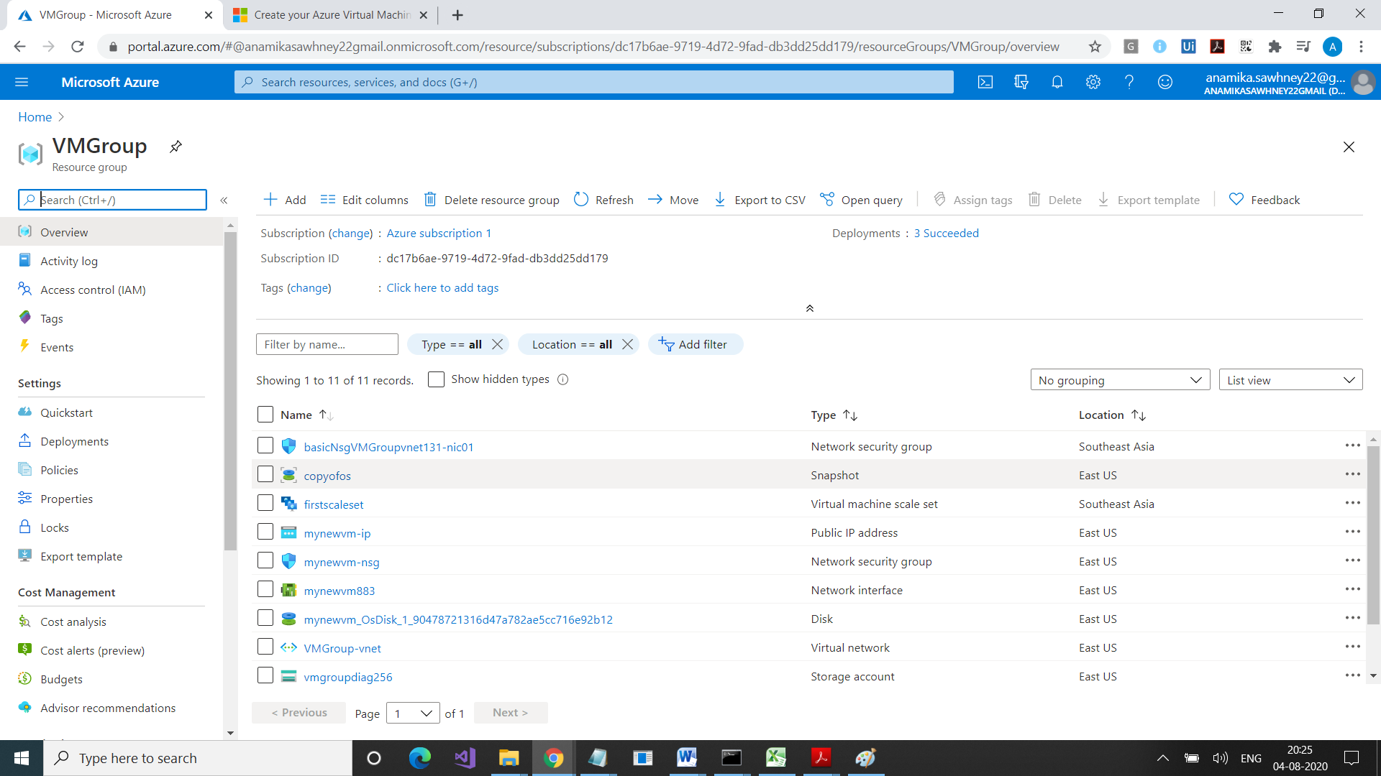

Now we will use it to create one more disk

Now when u r creating disk, ur regions has to be same of snapshot region

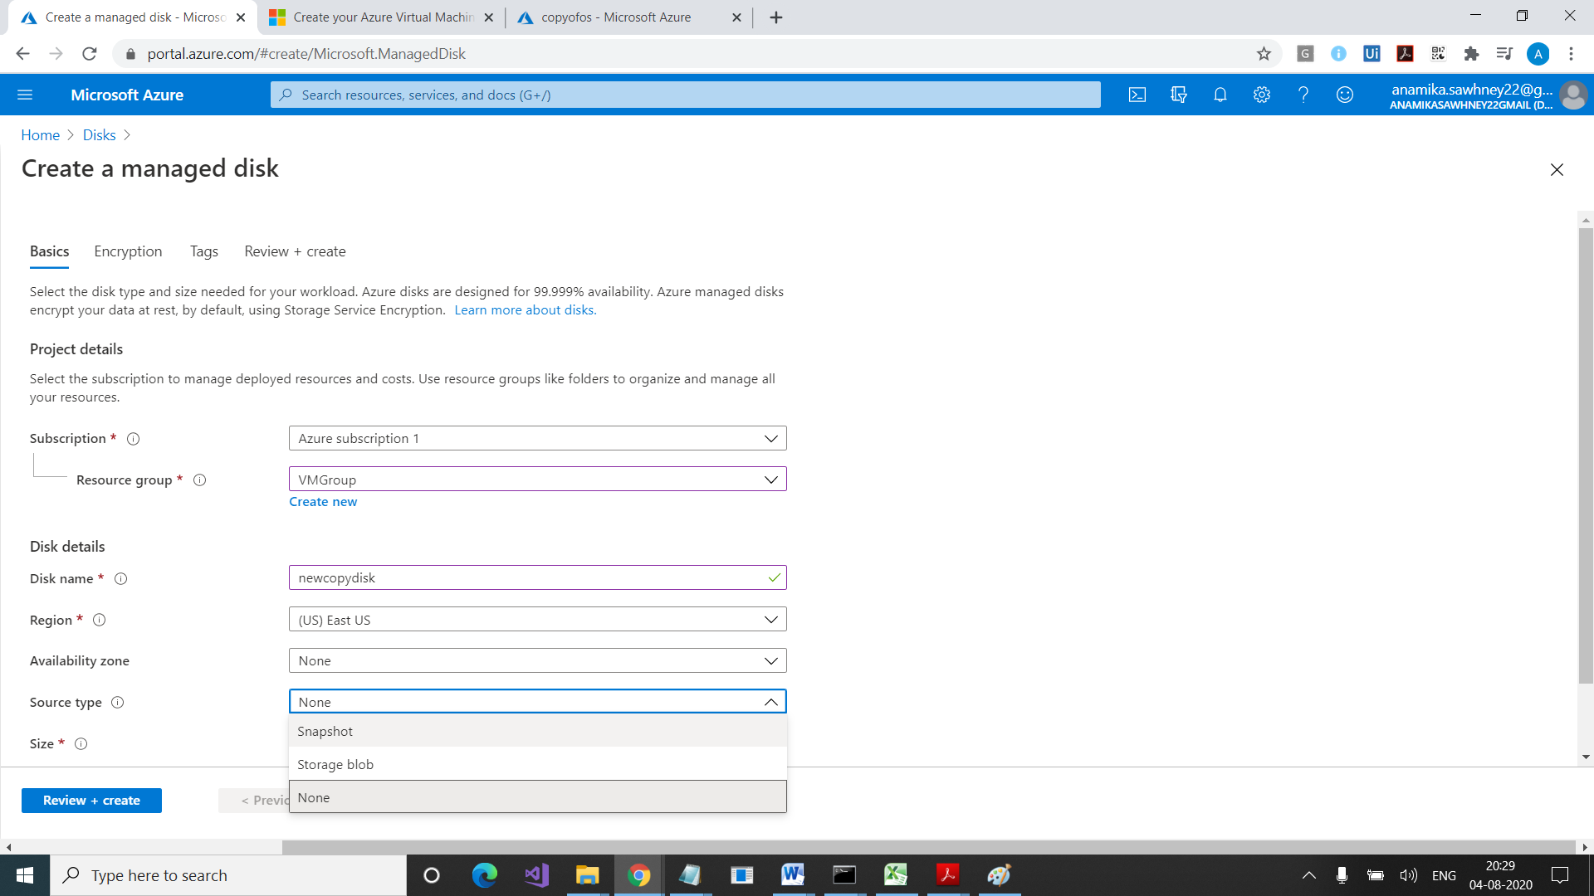

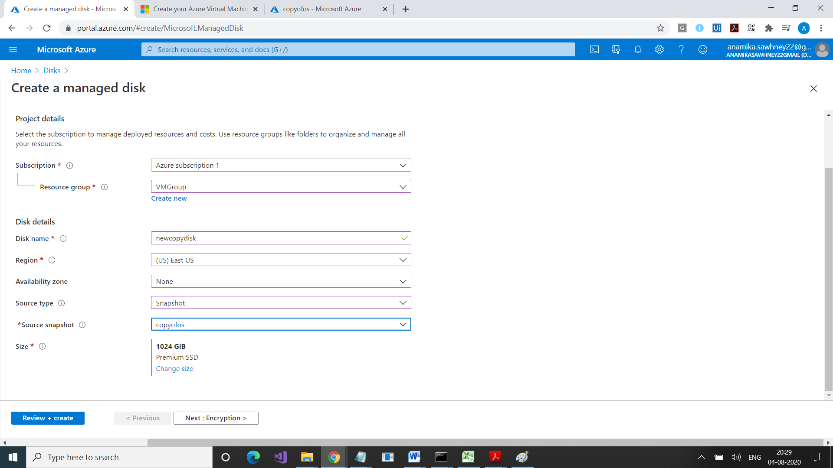

Now we have managed disk that comes from OS of some other VM

Chek ur managed disk

Now we will use this managed disk to create a VM

Go to ur new managed sdisk

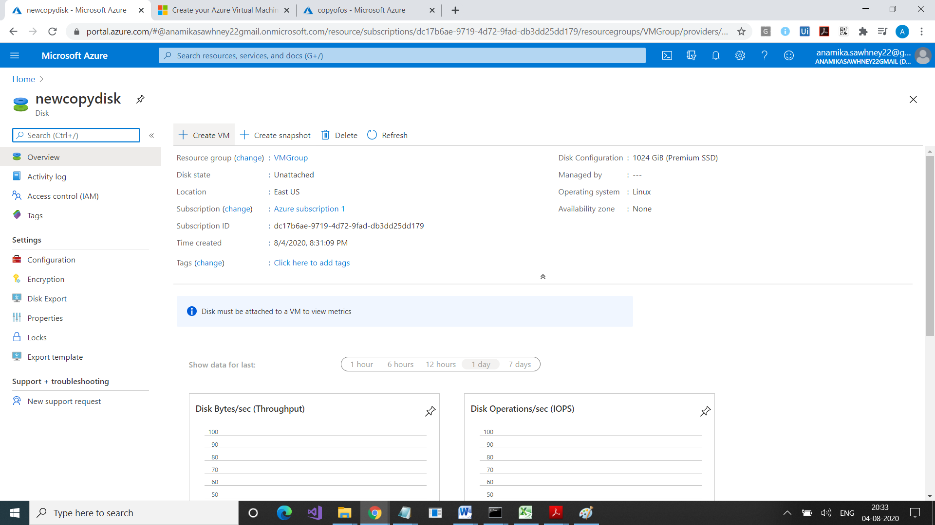

Click on Create VM